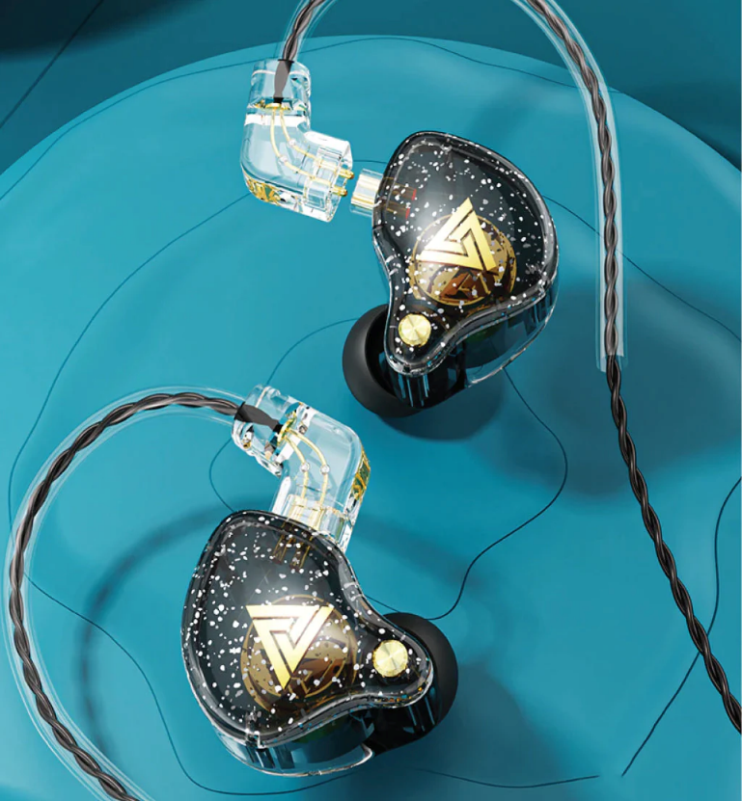
Nama: Muhammad Raditya Alfajri
NIM: 25090008
Kelas: 2A
Bahasa Inggris
Barang IEM

I chose the QKZ AK6 Pro because it is a modern electronic device. It is an in-ear monitor, or IEM, that produces high-quality sound. This earphone is suitable for listening to music, playing games, and making phone calls. One of its best features is the built-in microphone. The microphone helps make my voice clearer during conversations. It also helps reduce background noise while I am speaking. Because of this feature, communication becomes more comfortable and effective. Another useful feature is the detachable cable. If the cable is damaged, I can replace it easily. I do not need to buy a new earphone because I only need a new cable. The sound quality is very clear and detailed. It also has strong bass that makes music more enjoyable. The earphone is comfortable to wear for a long time. Its ergonomic design fits well in my ears. The transparent body also gives it a unique and modern appearance. I think this design makes the product look more attractive. The price is also affordable compared to many other IEMs. It offers good quality with useful features. In my opinion, the QKZ AK6 Pro is a smart electronic device. That is why I chose the QKZ AK6 Pro for my presentation.

